PRESS RELEASE
COMMUNICATIONS AND MEDIA TEAM OF THE 43RD ASEAN SUMMIT 2023
No.48/SP/TKM-ASEAN2023/ENG/9/2023

ASEAN Senior Officials’ Meeting Discusses Strengthening ASEAN’s Capacity and Institutional Effectiveness

Jakarta, 3 September 2023 – Director General of ASEAN Cooperation at the Indonesian Ministry of Foreign Affairs, Sidharto Reza Suryodipuro stated that the Senior Official Meeting (SOM) of the 43rd ASEAN Summit discussed, among others, strengthening ASEAN's capacity and institutional effectiveness so that it becomes “more mature”.
Director General Sidharto stated this in a press conference at the Media Center of the 43rd ASEAN Summit at the Jakarta Convention Center (JCC), Senayan, on Sunday (3 September 2023).
According to Sidharto, the message about strengthening ASEAN institutions was emphasized on multiple occasions by President Joko “Jokowi” Widodo. President Jokowi has repeatedly urged ASEAN to be more responsive to various changes in the region and to have a firm membership.
Regarding the theme of the 43rd ASEAN Summit in Indonesia, namely "ASEAN Matters: Epicentrum of Growth", Sidharto said that a number of decisions were agreed upon, including those pertaining to food security and resilience, promoting the region as a center of growth, the blue economy, and a number of other documents and procedures.
When Sidharto was asked about the currently contentious South China Sea issue, he ensured that procedurally, the issue wass not discussed at the SOM. However, it is possible that ASEAN member countries will voice their concerns and interests regarding this issue.
Continuing with the topic of China, it is confirmed that President Xi Jinping will not attend the 43rd ASEAN Summit. However, Sidharto emphasized that his absence is nothing out of the ordinary. According to tradition, the representative of China at the ASEAN Summit is China’s Premier.
Meanwhile, regarding the absence of the President of the United States (US) Joe Biden, Sidharto said that his party did not question it. The most important thing is constructive participation from all partner countries including the US.
In terms of ASEAN's strategic position, tight competition, and geopolitical issues, he stated that the contribution of all parties, including partner countries such as the United States, is crucial. Because, in the end, the development of ASEAN benefits not only member states but also all partner countries.
"ASEAN hopes for the constructive participation of all partner countries in supporting ASEAN Matters: Epicentrum of Growth. Because this is not empty rhetoric or political jargon," he said.
Regarding Timor Leste's full membership in ASEAN, Sidharto explained that ASEAN will observe and further assess Timor Leste's efforts to fulfill the prepared road map for full membership. He mentioned that at the 42nd ASEAN Summit in Labuan Bajo in May 2023, a road map containing agreements that Timor Leste had to fulfill. This matter was also reviewed by a special team or working group within the ASEAN body.
Responding to questions regarding Myanmar's chairmanship of the 2026 ASEAN Summit, Sidharto said that it is not up to SOM to make decisions or make recommendations. "Therefore, I cannot comment until there is further decision," he added.
Sidharta stated that the Myanmar representative who will attend the 43rd ASEAN Summit will be the Myanmar Ambassador to ASEAN from the government prior to the military coup. "Because he holds the credentials," said Sidharto. (Eko/Alex/Elvira Inda Sari)

***
For more information, please contact:
Director General of Public Information and Communications of the Ministry of Communications and Informatics – Usman Kansong (0816785320).
Get more information at http://asean2023.id, https://infopublik.id/kategori/asean-2023, and https://indonesia.go.id/kategori/ragam-asean-2023

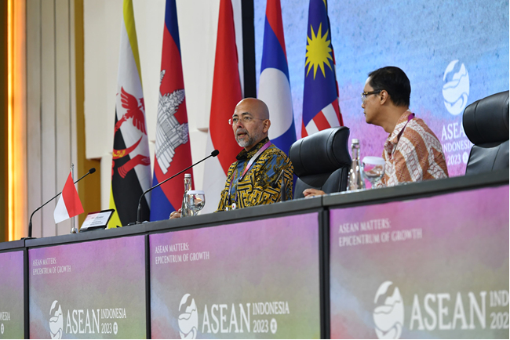
Director General of ASEAN Cooperation at the Ministry of Foreign Affairs, Sidharto R Suryodipuro (left) accompanied by Director for Information and Media, Ministry of Foreign Affairs Hartyo Harkomoyo delivers a press statement at the Media Center of the 43rd ASEAN Summit 2023 at the Jakarta Convention Center, Jakarta, on Sunday, 3 September 2023. Infopublik/Amiriyandi

